Ethan Allen Family Dining Set

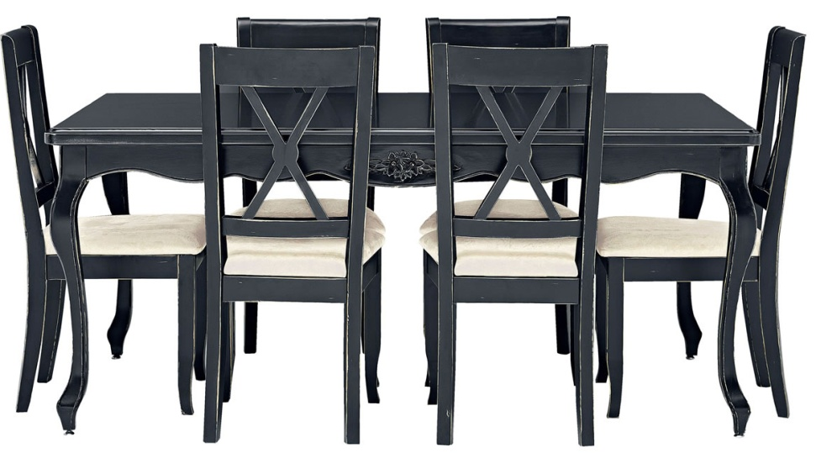

|  |
| --- |
| **DESCRIPTION** |
| Ethan Allen introduces stylish form seated dining set with a rich wooden black finish the set of tables and chairs is perfect to create the perfect look for family gathering. The rich wooden plank on top gives you feeling of happiness. Perfect for you and your family. |

|  |  |  |
| --- | --- | --- |
| **Price** | **1550$** | |
| **Dimensions** | **Table H** x **W** x **L** | **47in x 43in x 57in** |
| **Chairs H** x **W** x **L** | **34in x 20in x 30in** |
| **Features** | **Six Chairs and One Table with plank and formed chairs provide a comfortable bottom relaxing environment which will prove healthy for people who have back problem.** | |
| **Finished** | **Black Bloom Touch** | |
| **Available in** | **Black and White** | |